General Client Information Form Sound Tax Service
Returning Client or New Client
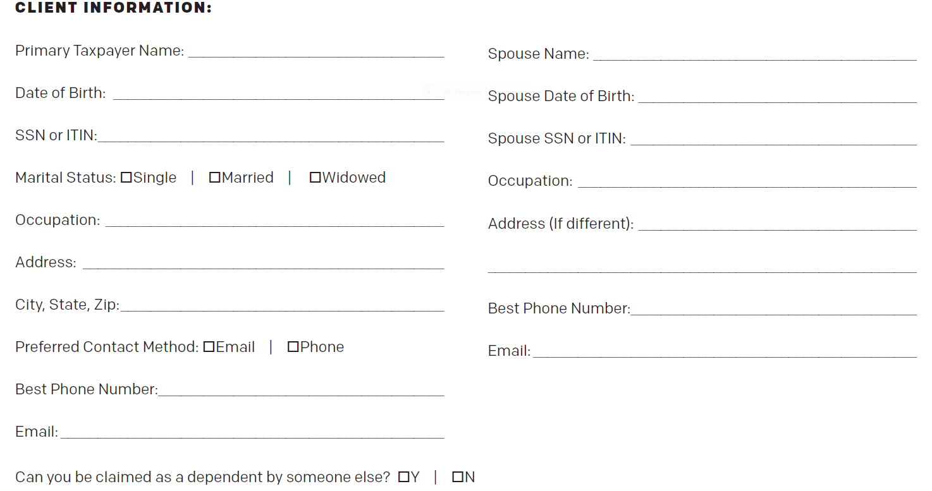

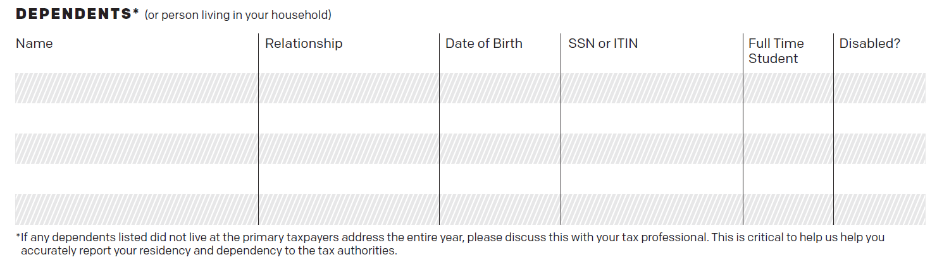

Direct Deposit Info> Routing #________ Account #_________ Checking or savings? Name of Bank _________________
Were you covered by health insurance all last year? Do you have 1095 forms? Exemption forms?
Private Insurance? Medicare/Medicaid? SEARHC Beneficiary? Months Covered?
Does this apply to all members of your household?

How do you prefer to receive tax return?

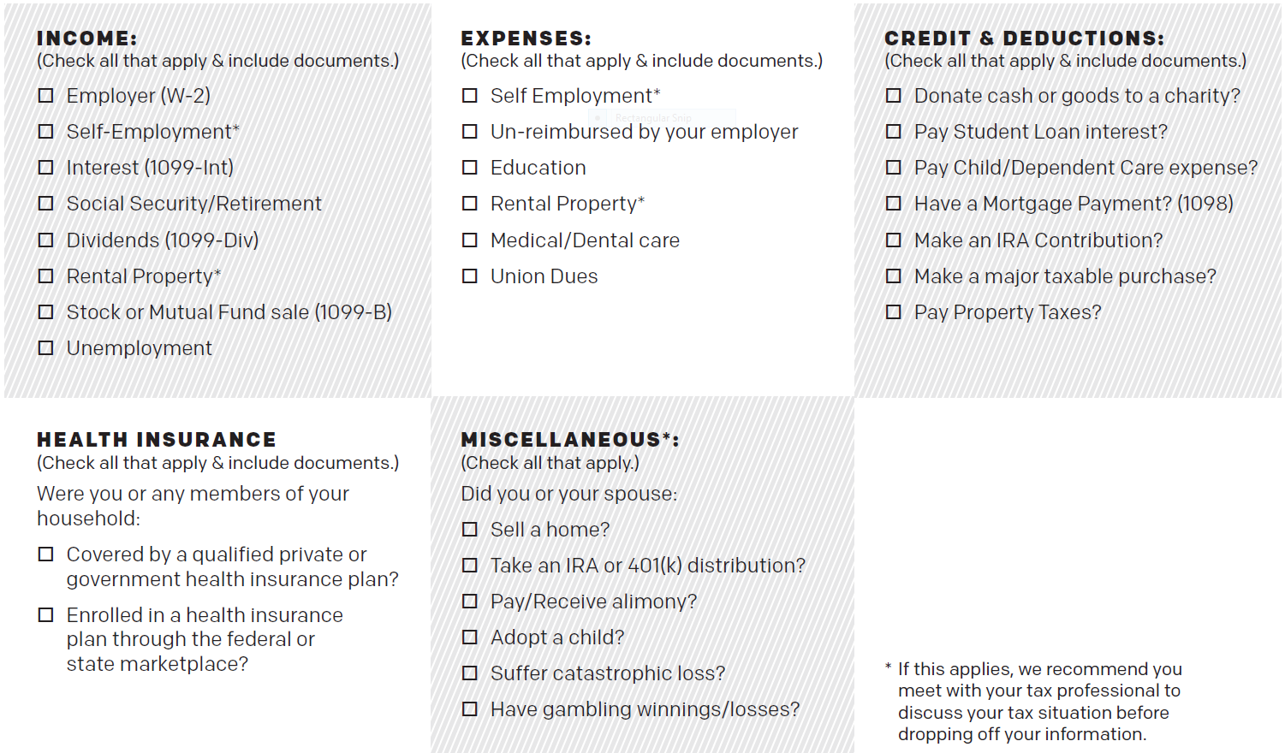
Did you receive PDF? How many members of household received PFD?

____________________________________________________________________________
Taxpayer Spouse Date

OFFICE USE
Engagement Letter______
Use/Disclose Forms _____
ID’s ______
Email/Fax Release _____
Due Diligence ______
Others (POA, Release of Exemption, 8821, etc)

